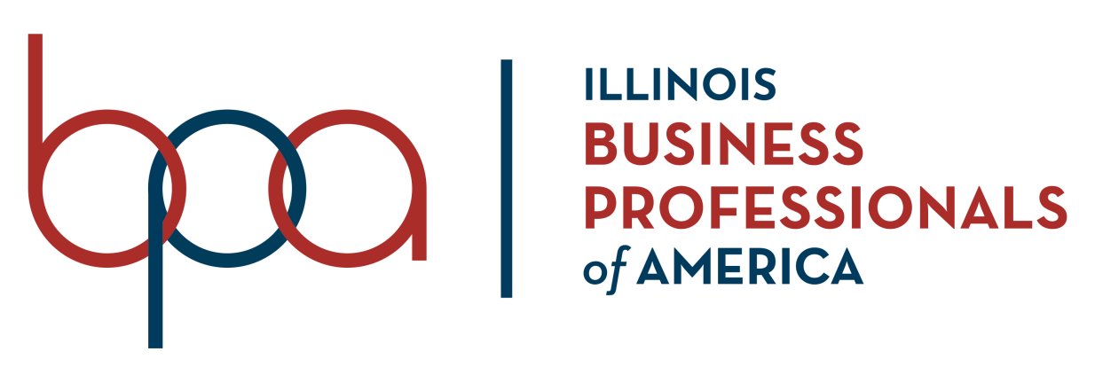

C E R T I F I C A T E
O F
P A R T I C I P A T I O N

THIS IS TO CERTIFY

WAS AN ACTIVE PARTICIPANT IN THE
BUSINESS PROFESSIONALS OF AMERICA ILLINOIS ASSOCIATION
FALL LEADERSHIP CONFERENCE
NOVEMBER 15, 2019
REPRESENTING THE CHAPTER
AND IS RECOGNIZED FOR PARTICIPATING IN LEADERSHIP ACTIVITIES

Tim Davis Glenna J. Pyzik
ILLINOIS ASSOCIATION BOARD CHAIRMAN ILLINOIS ASSOCIATION EXECUTIVE DIRECTOR

