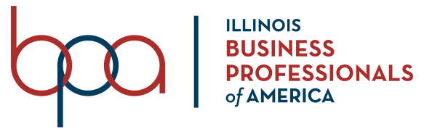

January 6, 2020

Dear Fellow Business Professionals

The Business Professionals of America, Illinois Association, invites you to attend this year’s State Leadership Conference, February 27 - 29, 2020. I look forward to seeing you take advantage of the countless opportunities Business Professionals of America has to offer. The State Officer Team hopes all of you will work diligently to CAPITALIZE YOUR FUTURE.

The State Officer Team is eager to welcome new and returning members of Business Professionals of America, Illinois Association. We know that you have put in a tremendous amount of time and effort into your competitions in order to qualify for this year’s State Leadership Conference. We hope your drive to succeed at this conference will serve as stepping-stones towards future success and wonderful memories.

In addition to competitive events, the State Officer Team has planned a wide variety of fun activities for you to participate in. Starting off the conference on Thursday night, please join us to go “Back To The Future: 2010’s Edition”. Relax and have a great time as we take a trip down memory lane to revisit music, trends, and games of the 2010’s.

On Friday, we look forward to your participation in the “Funds For Their Future” raffle, where all proceeds will benefit Special Olympics, our long-time partner and a worthy cause. The prizes will be handed out at the “Hungry For The Future” banquet along with great food and the opportunity to socialize with peers, new friends, and advisors. After dinner, we encourage you to join the State Officer Team and your new friends at the “Take A ‘Dance’ On The Future” dance to celebrate all your hard work!

The top finishers of each contest will be given the opportunity to compete in the National Leadership Conference from May 6 - 10, 2020 in Washington D.C. You will represent our state of Illinois and earn national recognition as one of the nation’s best business professionals.

The entire State Officer Team wishes you the best of luck in your competitive events, and encourage you to make the most out of your time here in Business Professionals of America to CAPITALIZE YOUR FUTURE!

Best Regards,
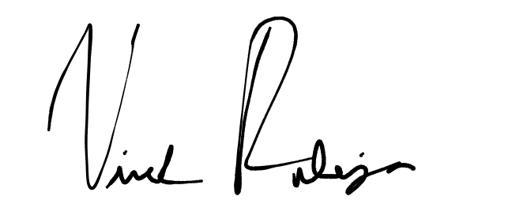
Vivek Raheja
State President

